

Department of Computer Science and Engineering

Course Code: CSE302

Course Title: Database Systems

Section: 01

Semester: Fall 23

**LAB 05**

**Submitted to:**

**Dr. Mohammad Rezwanul Huq**

Associate Professor

Department of Computer Science and Engineering

East West University

**Submitted by:**

**Name:** B M Shahria Alam

**ID:** 2021-3-60-016

**Date of submission:** 12th November, 2023.

**Lab Task**

**# 01**

(Without using subqueries)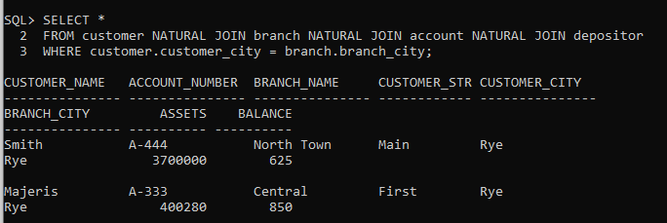

(With using subqueries)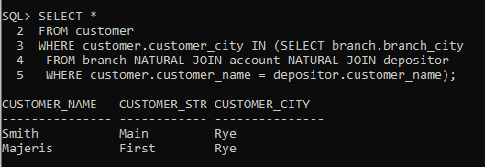

**# 02**

(Without using subqueries)

(With using subqueries)

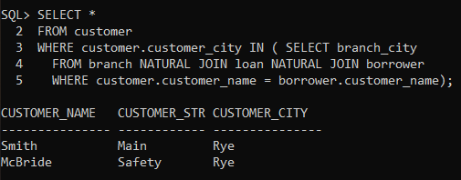

**# 03**

(Without using HAVING clause**)**

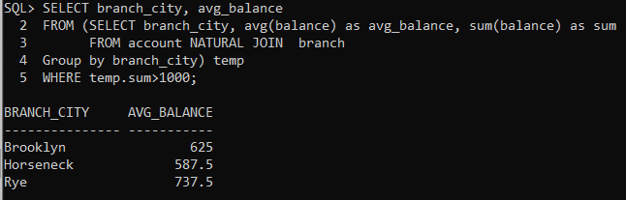

(With using HAVING clause)

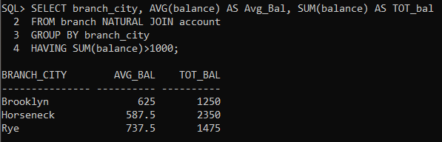

**# 04**

(Without using HAVING clause)

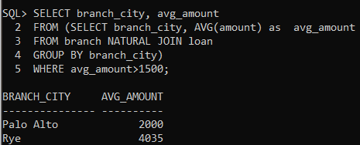

(With using HAVING clause)

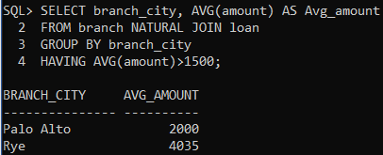

**# 05**

(Without using ALL clause)

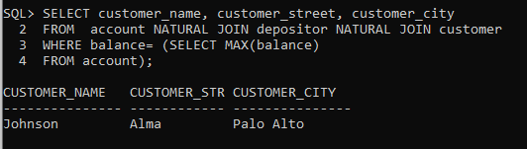

(With using ALL clause)

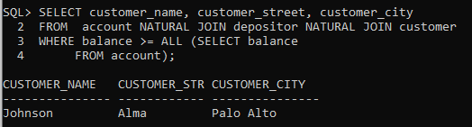

**# 06**

(Without using ALL clause)

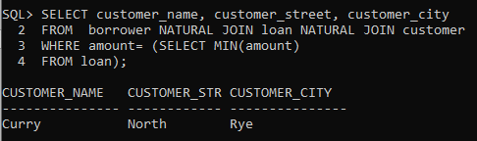

(With using ALL clause)

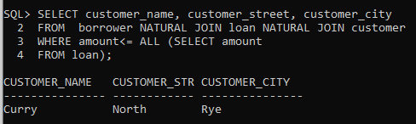

**# 07**

(With using IN keyword)

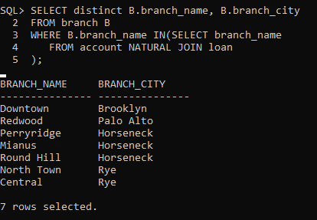

(With using exists keyword)

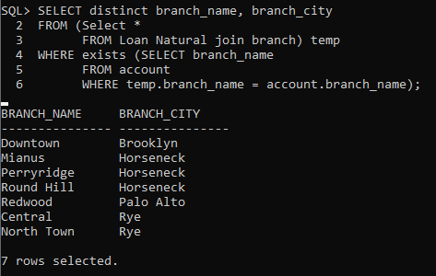

**# 08**

(With using NOT IN keyword)

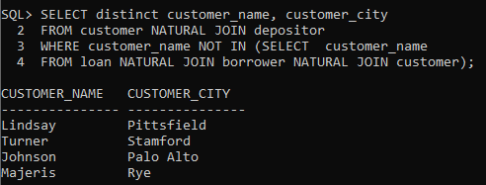

(With using NOT exists keyword)

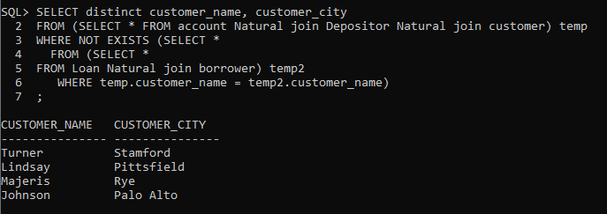

**# 09**

**(With using WITH clause)**

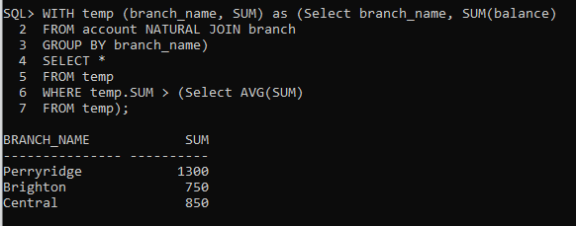

**(Without using WITH clause)**

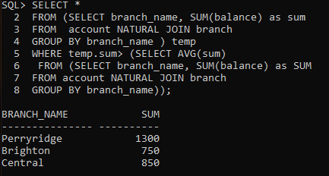

**# 10**

**(With using WITH clause)**

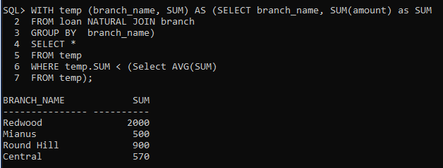

**(Without using WITH clause)**

